**INFORMAL EMAIL TASK**

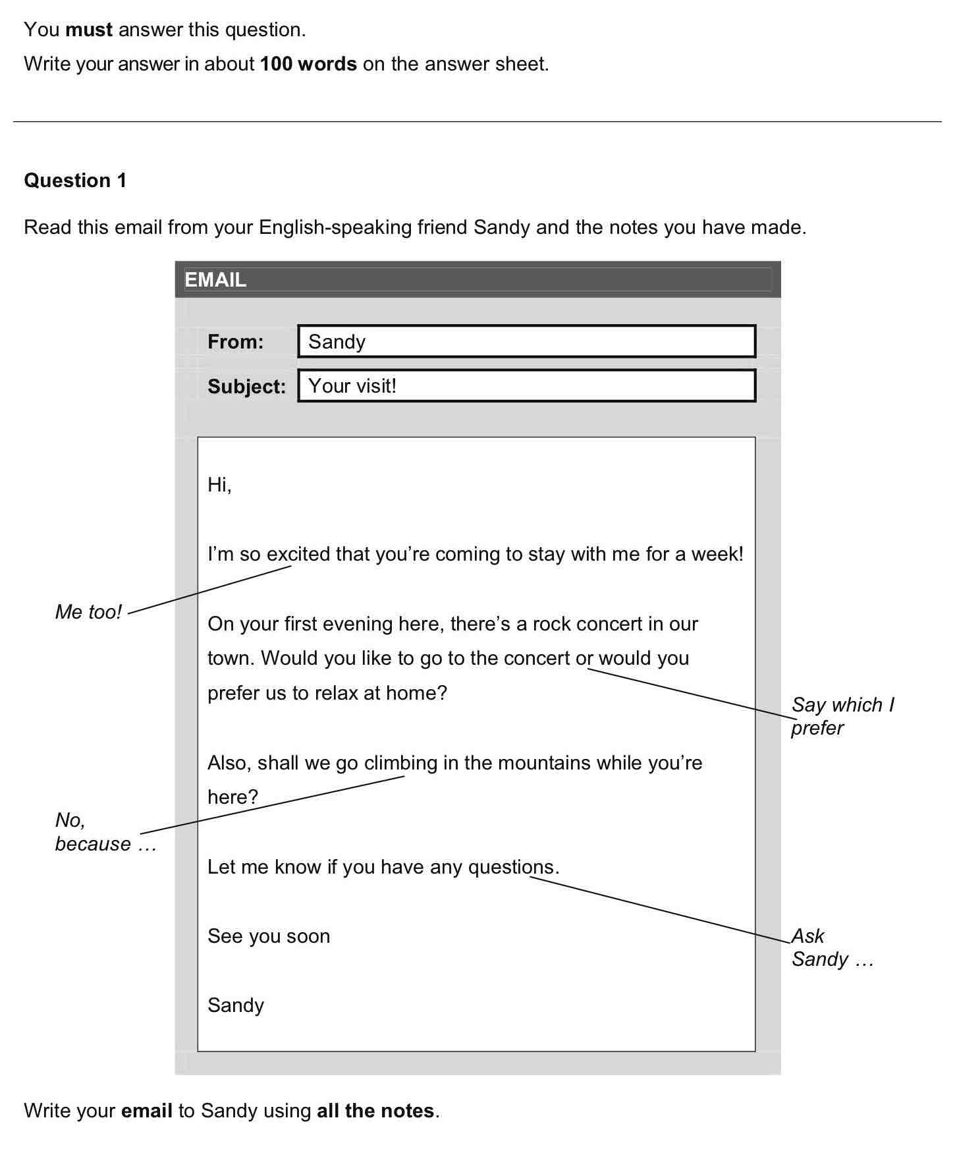

How to write an email:

* <https://kseacademy.com/cambridge/b1-preliminary-pet/writing/email/>
* <https://learnenglish.britishcouncil.org/skills/writing/intermediate-b1/an-email-giving-holiday-advice>
* <http://aprendeconcambridge.com/como-escribir-un-email-informal-en-el-examen-de-ingles-b1-de-cambridge-english/>